GitHub – Main Concepts
Conteúdo

GitHub – Main Concepts 2
CENTRALIZED VS DISTRIBUTED VERSION CONTROL 2
Forking a Repository 3
Cloning a Repository 3
Cloning a Repository using Visual Studio 4
Remotes repository 5
Managing remote repositories using VS 5
Branch 6
Creating a Topic Branch Using VS 6
Creating a Tag 7
Commit 8
Commit a change on Visual Studio 8
The commit message 8
Checking the committed changes on Visual Studio 9
Push the committed changes to GitHub 11
On the GitHub, Pull the committed branch to the main 11
PULL 13
Git Hub 14
Checking the commit history on GitHub 14
A note about changing the commit history 15
Changing the notifications settings on GitHub 15
Push to Git automatically on Commit 15
APENDICE A – reference articles used 16
APENDICE B – creating a good commit message 16

GitHub – Main Concepts

GitHub, Inc. is a provider of Internet hosting for software development and version control using Git.
It offers the distributed version control and source code management (SCM) functionality of Git, plus its own features.
It provides access control and several collaboration features such as bug tracking, feature requests, task management, continuous integration and wikis for every project. Headquartered in California, it has been a subsidiary of Microsoft since 2018.
GitHub offers its basic services free of charge. Its more advanced professional and enterprise services are commercial.
Free GitHub accounts are commonly used to host open-source projects.
As of January 2019, GitHub offers unlimited private repositories to all plans, including free accounts, but allowed only up to three collaborators per repository for free.
Starting from April 15, 2020, the free plan allows unlimited collaborators, but restricts private repositories to 2,000 minutes of GitHub Actions per month.
As of January 2020, GitHub reports having over 40 million users and more than 190 million repositories (including at least 28 million public repositories), making it the largest host of source code in the world.

CENTRALIZED VS DISTRIBUTED VERSION CONTROL
Git is a distributed version control system, as a contrast to for example subversion that is centralized. What this means is that with subversion, the code repository (repo) lives on a server and people need special permissions (commit rights) to be able to add code to the repo. Everything lives in one place.
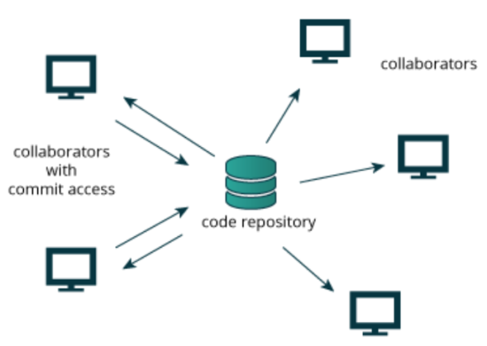
In a distributed system, you get a repository of your own when you clone the project. This means you can work and add code to the repo even when offline, since the repository lives on your computer. But this also means you need a bit of discipline in keeping in sync with the rest of development, since your repository is separate from the others.

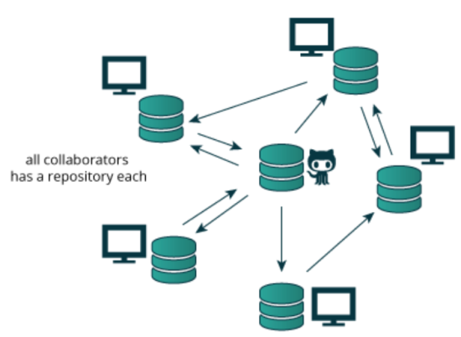

Forking a Repository
Inside GitHub, Fork is basically creating a copy of an GitHub repository to your own GitHub account. To fork a repository, all you need to do is to access the repository you want to fork (Example: https://github.com/ThematicTheme/Thematic) and click on the Fork button as illustrated bellow:
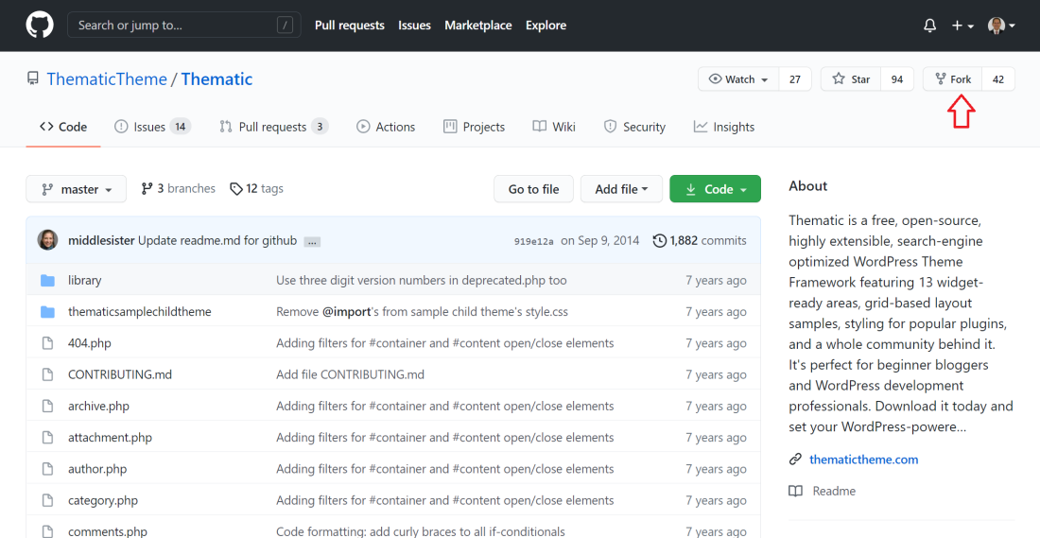

Cloning a Repository
When you want to actually work on your repository you need to clone it to your computer, and now you own two repositories: one remote on github and one local on your computer.

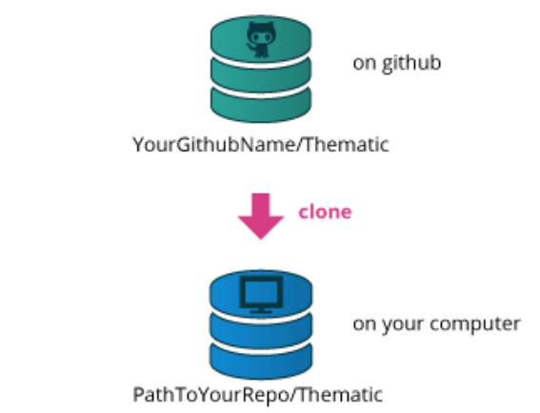

Cloning a Repository using Visual Studio
To clone a repository from GitHub using your Visual Studio execute the following:
- On the Git menu, select Clone Repository…
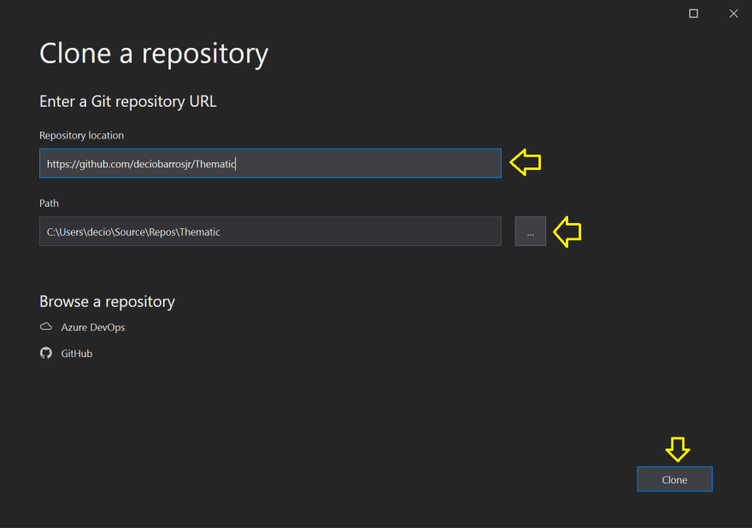
On the end of the cloning process, a local copy of the repository will be created inside your local VS repository and VS will open to repository to you as illustrated bellow:
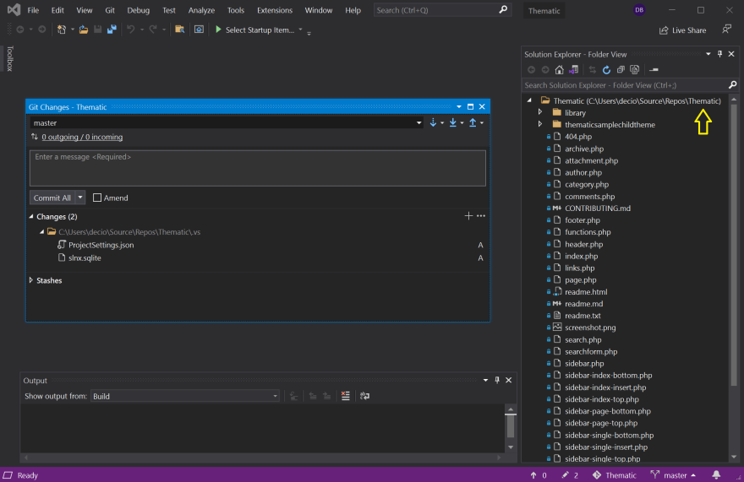
Once you did the fork of the desired repository and created your local copy of the repository, the choice to contribute back to the original project is yours to make, we will discuss about this on the topic: ?????????????????

Remotes repository
Git calls other repositories that it knows about as remotes.
By default, when you clone a repository it will save the parent repository under the name origin, so origin on your computer repository will be pointing to your personal Thematic fork on github.

Managing remote repositories using VS
To manage the Remotes Repository on VS execute the following:
- On the Git menu, select Manage Remotes…
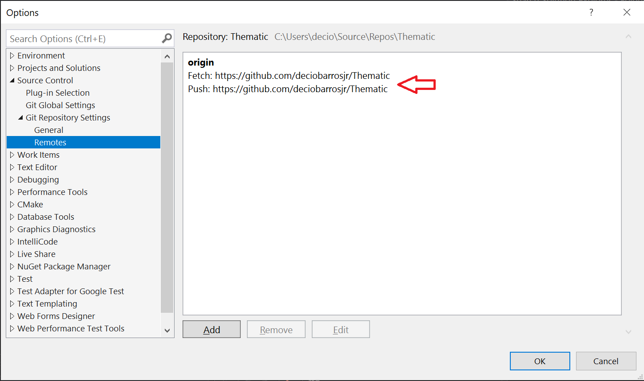
You can add as many remotes as you like and call them whatever you like. You could add a remote for everyone else that has also forked Thematic if you want to keep track of their work.
One thing you need to do if you want to keep up with the main development is to add the Thematic github repository as a remote, and the naming convention for this remote is upstream.
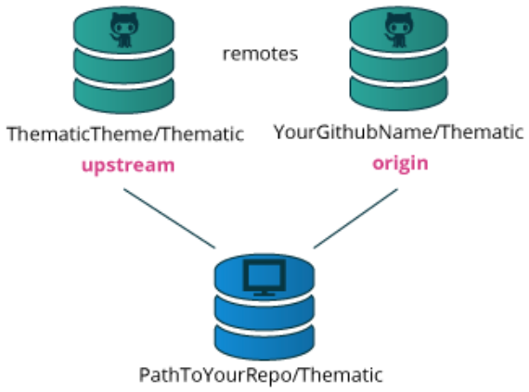
This means you will have two remotes configured in your local repo, origin would point to your fork on github and upstream would point to the main Thematic github repo.
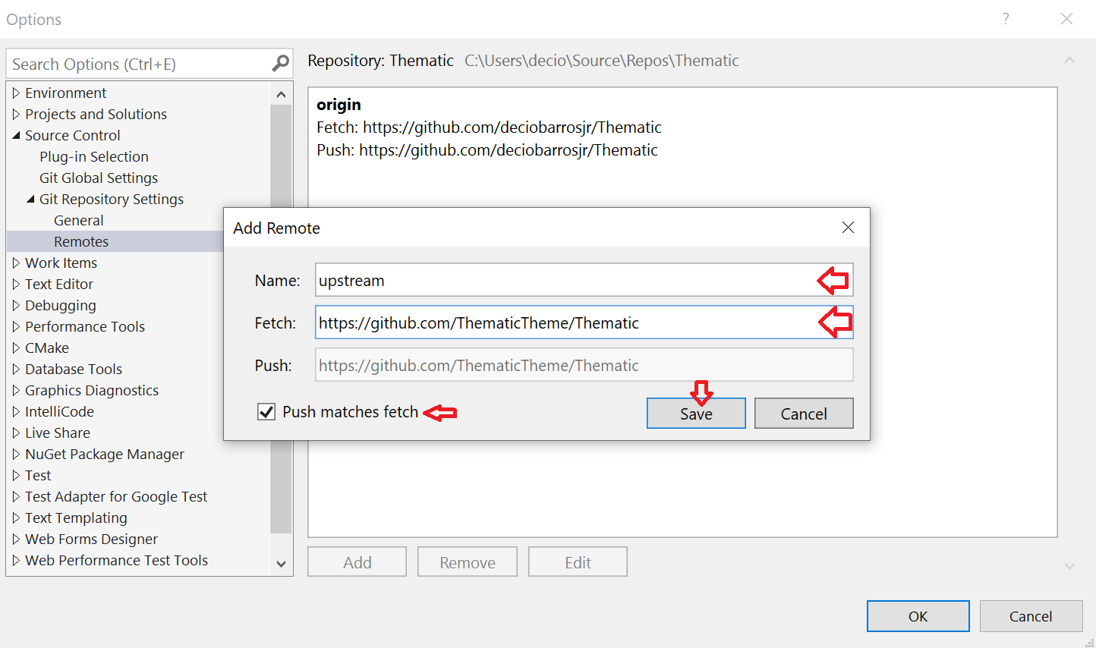

Branch
Git repositories are organized with tags and branches. A branch is a way to keep lines of development separate. The default branch in git is usually named master. Branches created from master, is commonly referred to as topic branches.
An example use case for branching is when you are working on a website and have an idea but working on it might break something. Create a branch for your idea, commit your work there and do your testing, and when everything works as intended you merge the branch back into master.
When you create a branch, it will exist only on your local repo unless or until you decide to share it with others.
Other repositories might have several branches that you choose to copy and track or decide to leave alone. You can have as many branches as you like.
A common thing for software development is to make a topic branch for each bug ticket that gets worked on. When a bug has been resolved, that branch is merged into master. That way, work can be done on several bugs in parallel without interfering with each other.
An example of a git branch model: https://nvie.com/posts/a-successful-git-branching-model/

Creating a Topic Branch Using VS
- On the Git menu, select New Branch…
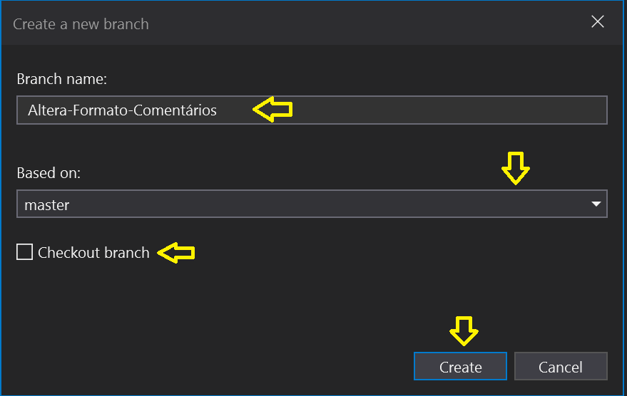
Branch name: define a descriptive name of the branch you are creating
Based on: define from where you branch will be based on. This can be the local master or may be even another branch.
Checkout branch: the branch may be automatically checked out after the creation. But remember that once checked out the branch can not be deleted.

- On the Git menu, select Manage Branches to view the existing branches in your solution
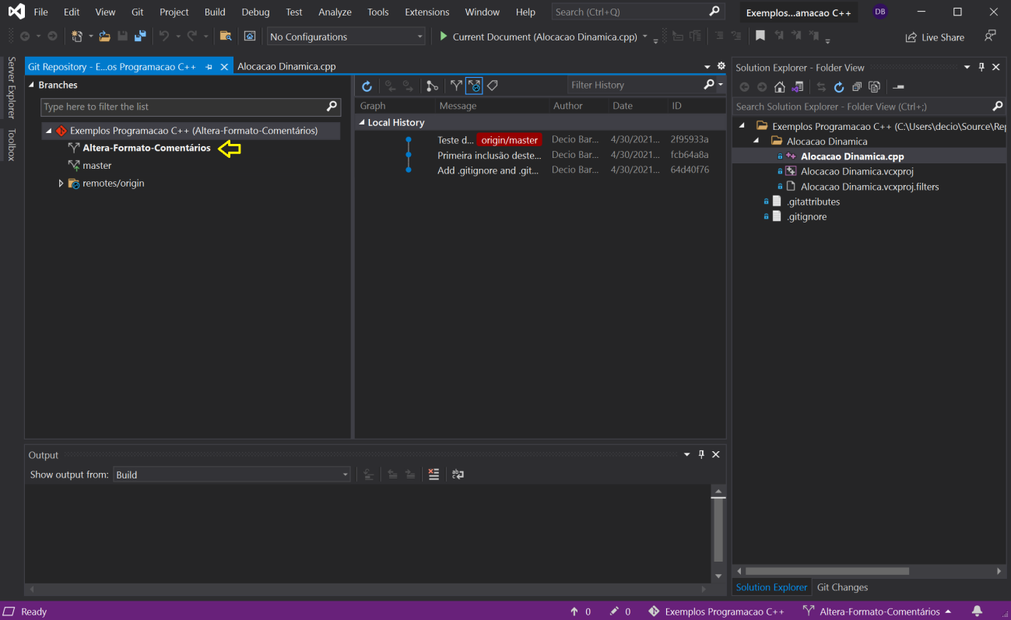

Creating a Tag
Tags are pointers to a certain commit, and just an easier way to reference them than memorizing hash numbers. A common way to use tags is for version numbering. Github vill generate zip files ready for download using your tags.
Tags are not needed for the example workflow mentioned before, see them as an optional extra at this point.

Commit
When you have made some changes that you want to save, you commit them to your repository. This will create a new entry on the Brunch history.
Commits are logical chunks of changes that gets saved in sequence, forming a history that you later can go through. Changes to several files can go in the same commit.
Each commit gets a timestamp, an author name and email (which comes from a configuration file), a commit message and an automatically generated hash.
The hash is how git keeps track of its commits and references them. A typical hash looks like 27b6b79fca466af4648f9f8042e1f159b392293d, but fortunately git is smart enough that you often only need to give the first six or eight characters for it to know which commit you are talking about.
Github lets you browse the commit history and the hash of each commit is shown to the right in the list.

Commit a change on Visual Studio
- On the Git menu, select Commit or Stash… to access the commit panel as illustrated bellow
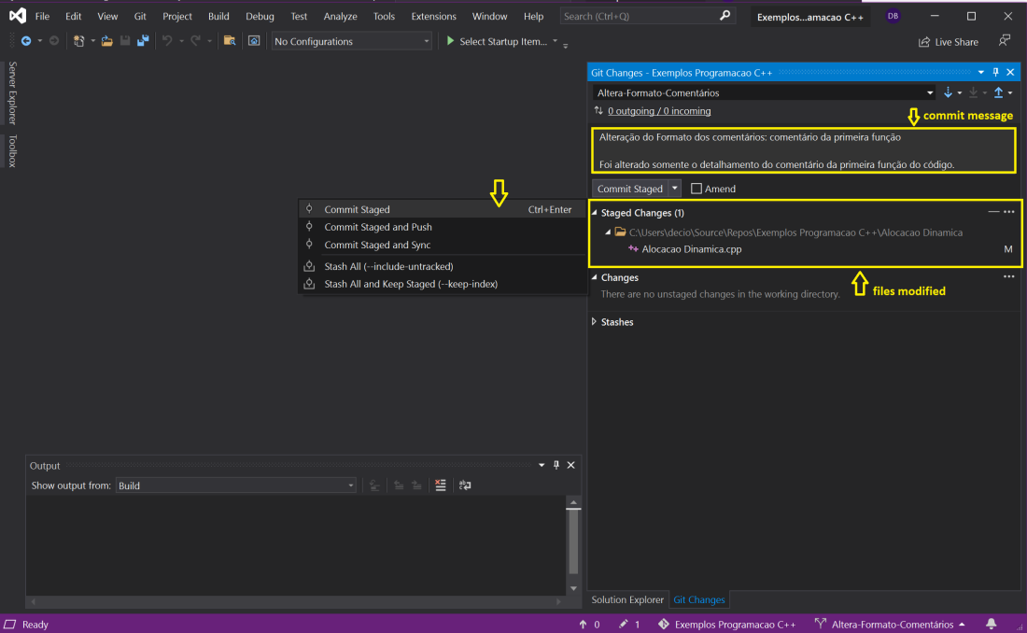

On this screen you will be able to check the files that was modified on this branch and will be part of this commit.
You will need to enter a descriptive message to be part of this commit.
After this you will hit the desired Commit option from the popup menu.

The commit message
If the hash is how the computers keep track of the commits, the commit message is how people keep track of them. Do take your time to write good commit messages.
Think of the commit message as an answer the question “What will this commit do if I add it to my repo?”.

Checking the committed changes on Visual Studio
There are many ways to check the committed branches inside VS. The approach you will use to check the changes will depend what you want to check.
Checking all the committed changes on the solution
- On the Git menu, select View Branch History… to access view your recent commit
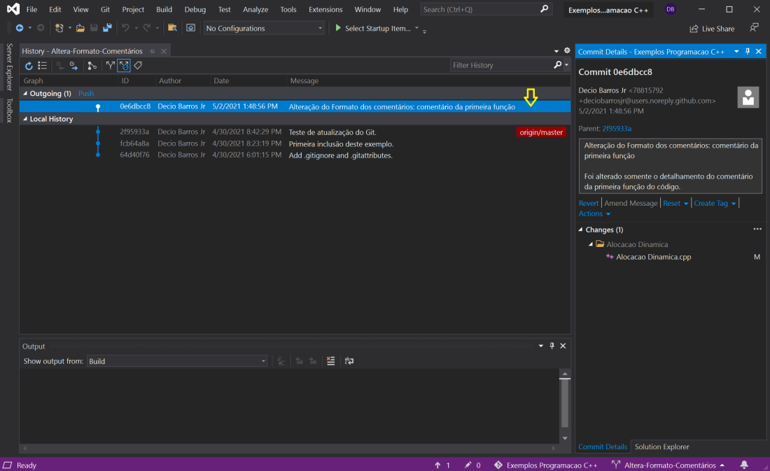
Double click on the line of your commit to view your commit details on the commit detail panel on the right. At this point, your changes resides only in your local repository.

Checking all the committed changes to a specific file
To do that, follow the following procedure
- Right click over the name of a file name on the Solution Explorer.
- Choose Git on the menu that will appear
- Chose View History on the next menu
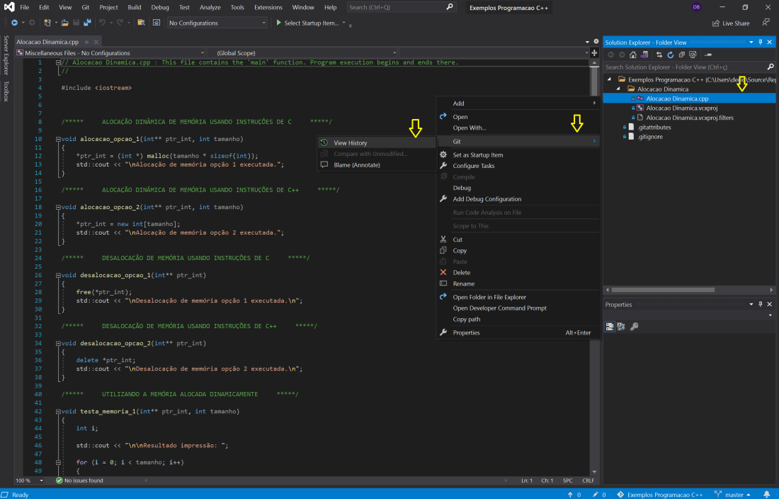
- The next screen will show the Commit History. On the top we find the icons to filter the information to be shown on the panel. To check all the details about a specific commit, right click on the commit and choose View Commit Detail on the popup menu
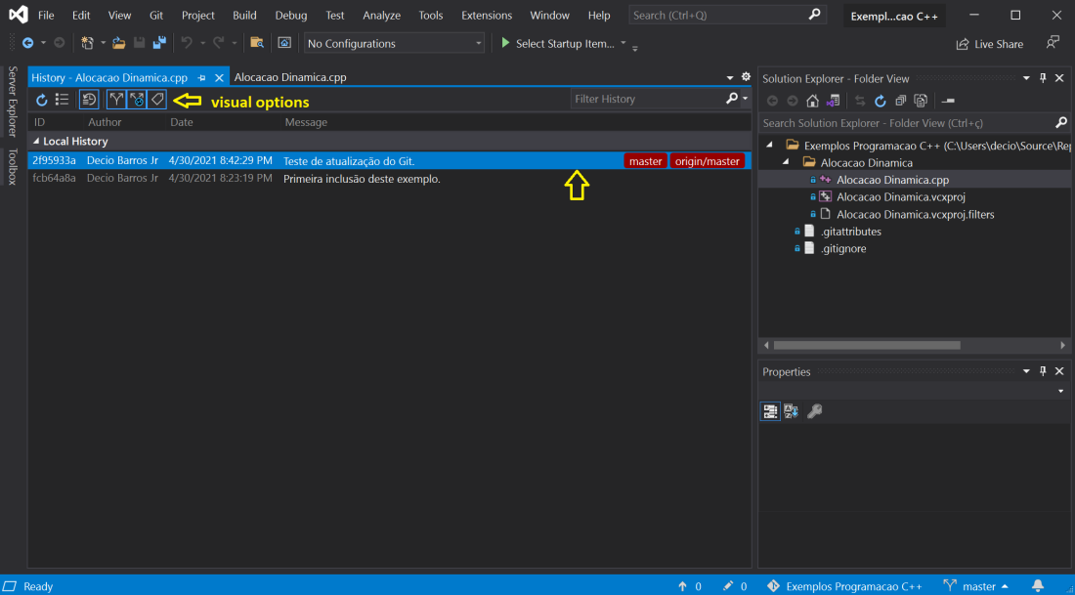
- The Commit Detail view will appear “docket” with the Solution Explorer on the right side of VS as illustrated bellow. On this view we can see that file “Alocacao Dinamica.cpp” was modified on this commit.
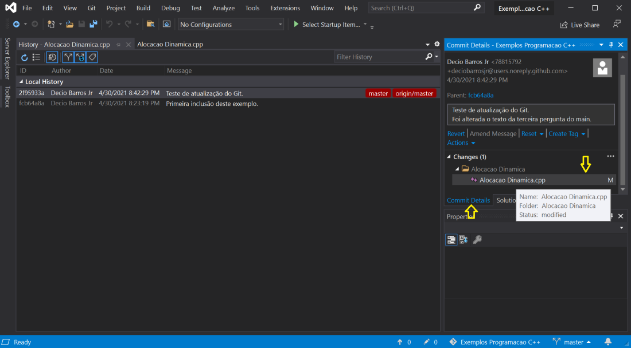
- Double click over the “Alocacao Dinamica.cpp” file on the “Commit Detail view” to show the differences between the original file and the committed one.
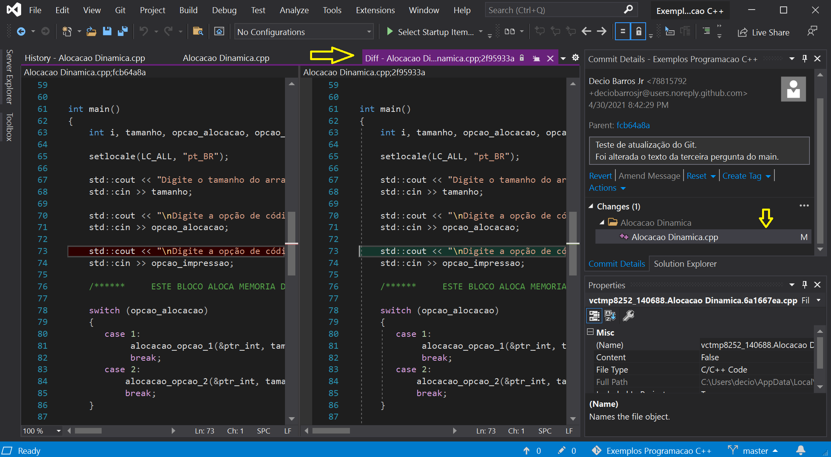

Push the committed changes to GitHub
On the Commit a change on Visual Studio, described before, we choose the option “Commit Staged”.
To push the committed change to GitHub, on a later step, you should do the following:

On the Git menu, select Push.

During the commit, VS shows on the popup menu addiotal options that you may choose to use:

Commit stage
Commit stage and push

On the GitHub, Pull the committed branch to the main
GitHub will manage and keep the committed branch and wait for your validation to merge them on your main branch or take another action you choose.
The following process detail how to commit the new branch to your main:
- On the Git menu, select Push to push your committed changes to GitHub.
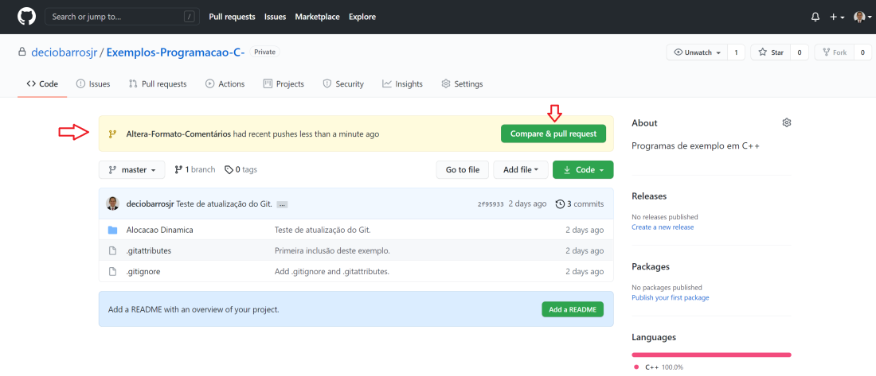
On the above screen, GitHub will notify you that a pull request arrived on your repository and ask you to compare and pull the request.
At this point, no changes was made on your main repository on GitHub.
Click on the Compare & pull request button to review the pull request you received.
The following screen will be shown on GitHub:
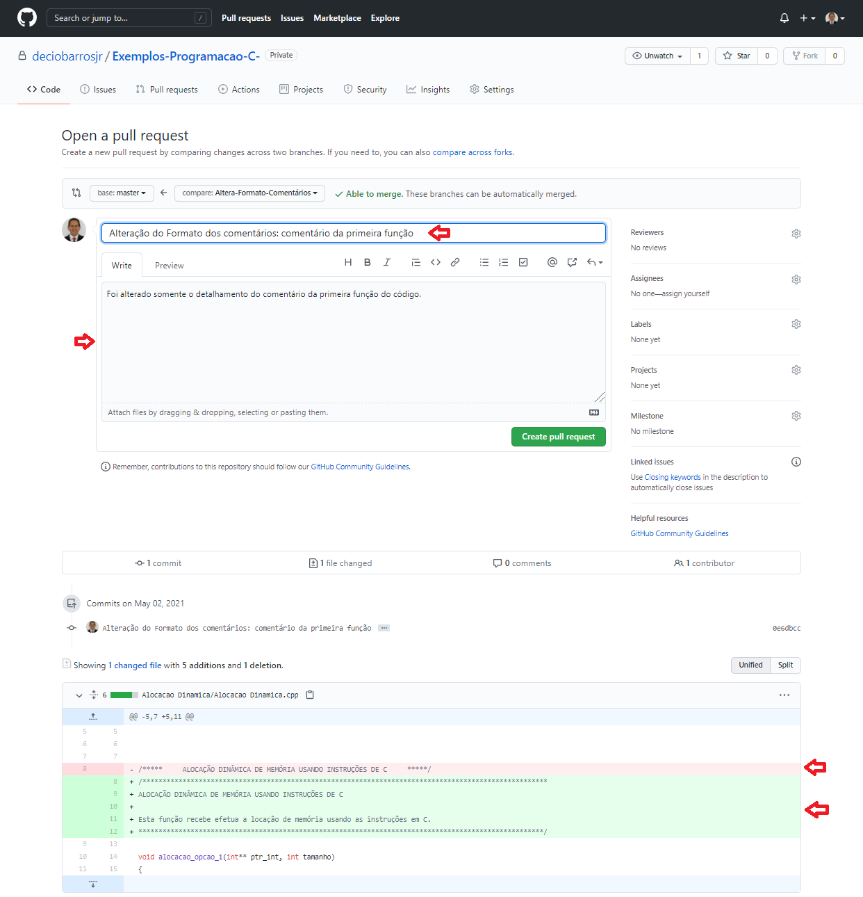
On the above screen, you will have the opportunity to check who sent the pull request, the commit message and the changes that was made to the files on this branch .
If you agree with the changes proposed on this pull request, click on the button Create pull request and the following screen will be shown:
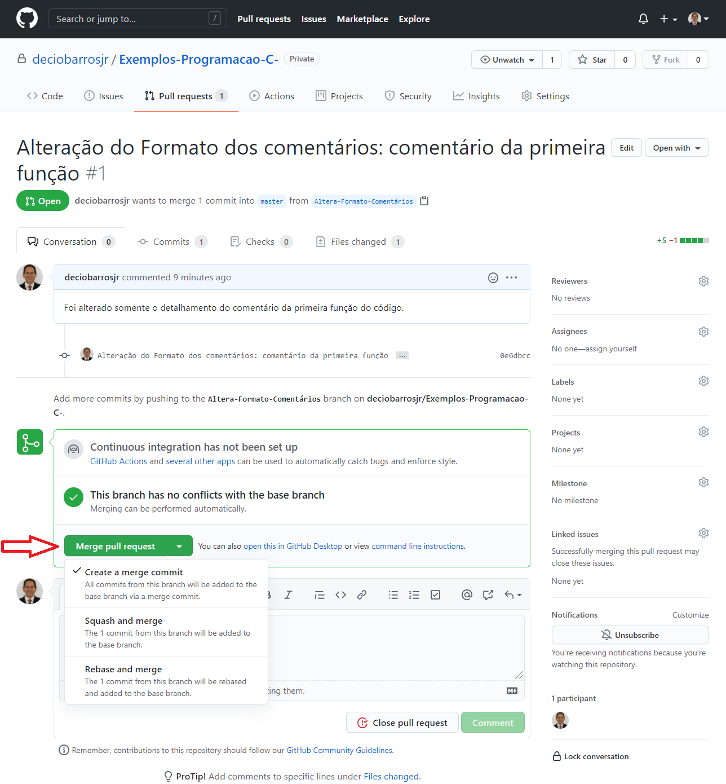

On the above screen click on the Merge pull request button and on the next screen confirm the merge. After this, the changes will be incorporated to your GitHub repository.

PULL
A pull is basically the process of downloading a branch from a repository and then merging it with the branch that is checked out in your directory.
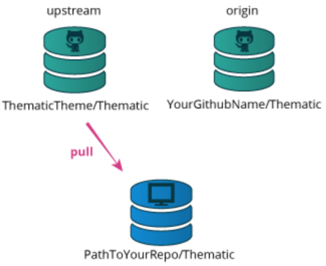
You can pull from any repository you like, you don’t need special permissions to do a pull. Usually you need specify which repository and which branch you want to pull from, and the pull will happen to the branch that is currently checked out in your directory. You can set up automatic tracking of branches but that is a bit out of scope for this walkthrough.
Here comes the advantage of using topic branches. You can keep your local master branch clean so it will always be a mirror copy of the upstream repo, and your own code lives in topic branches.
When upstream changes, you can directly pull to your local master branch without worrying about code conflicts.
You can then update your topic branch if needed by merging your local master branch into the topic branch.
Pulling and merging is also possible between local branches, and that will bring the latest changes over from master to the topic branch.

Git Hub
Git doesn’t save multiple copies of the files themselves, but only the actual changes from one point to the other.
The repositories on github contain only the commit history and not any actual files.
This is why repositories are so small compared to keeping several backups of actual files.
Only the changes are recorded and saved.
When you checkout something, those changes get applied to the files in your directory.

Creating a new repository on GitHub
The process for the creation of a new repository on GitHub foy your solution is very simple.
Select Git on the main menu of VS and then Create Git Repository…
The following screen will be shown by the VS:
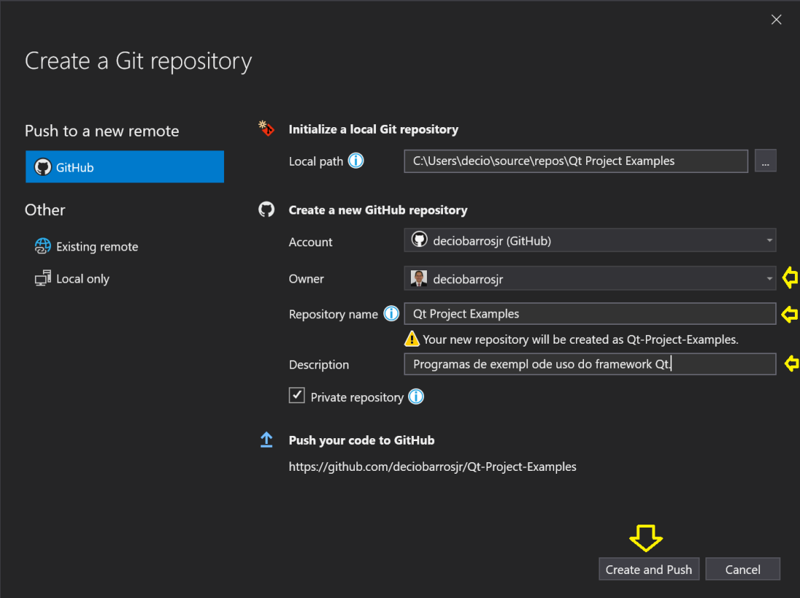
Account: this is your account on GitHub. If you are already connected to GitHub on VS, your account will show up here.
Repository name: the repository name on GitHub.
Description: a descriptive phrase about the repository content.

Hit the button Create and Push to create and push the actual content of your solution to GitHub.

Checking the commit history on GitHub
To check your commit history on GitHub, follow the following instructions:
- Select a file you want to check the commit history
- Click on the History button
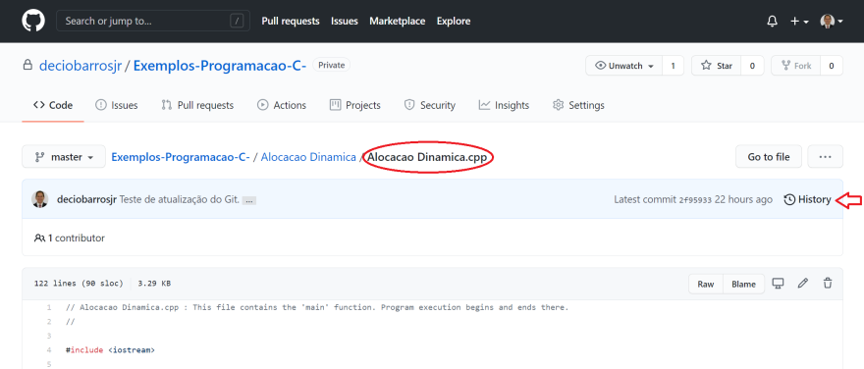
- On the next screen, GitHub will shown all the commits that changed the selected file. To check all files changes by a specific commit, click on the commit
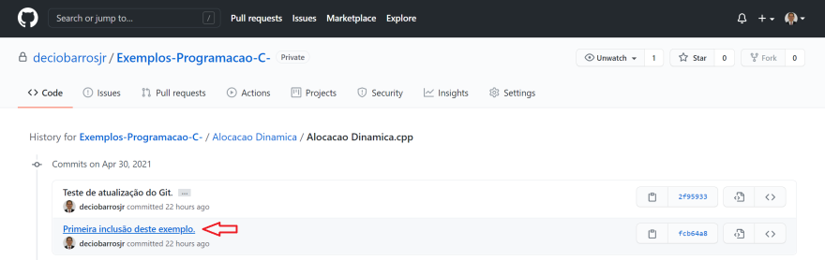

- The next screen will show all the files that was changes by the selected commit and the portions changed of each file
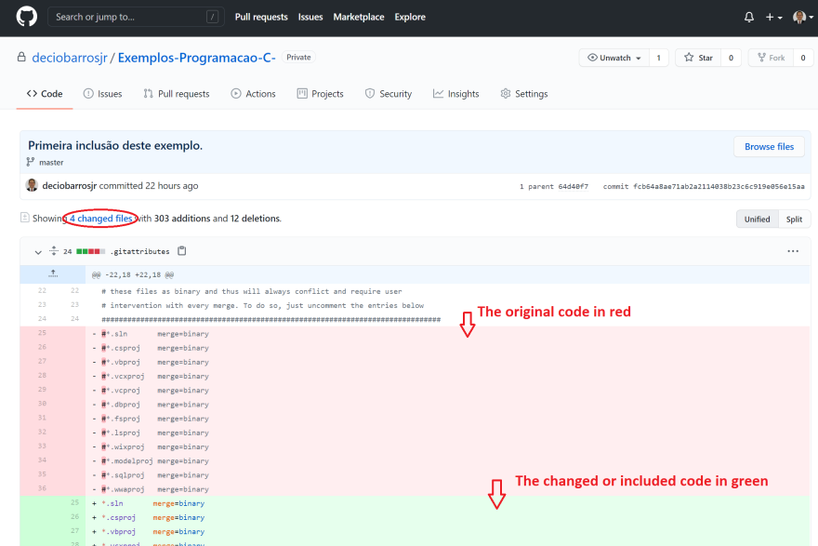

A note about changing the commit history
Commits are not set in stone. They can be manipulated afterwards, split apart, combined into one (squashed), the message can be altered (amended) etc etc. Keep in mind though that the hash is individual to a commit and if commits are changed then the corresponding hash changes as well. This will alter the history that git keeps track of and should not be done on any branch that has been shared with others.
One advantage with using local topic branches is that you can manipulate commits in them without worrying about messing up other people’s history.
Once you have shared a branch though, leave the commits alone.

Changing the notifications settings on GitHub
- Access your account and the select Settings
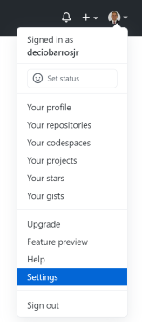

- On the Settings page, select Notifications
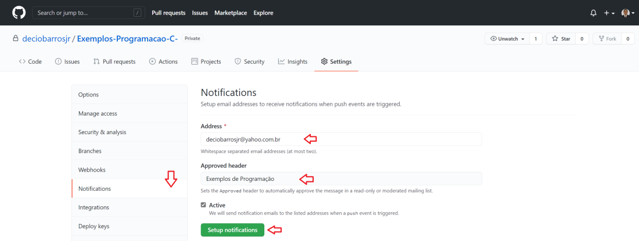

Push to Git automatically on Commit

Visual Studio Code has a setting to push or sync on commit.
- Go to the VS Code Settings menu (Gear on the bottom left > Settings)
- Go to Extensions > Git and look for Post Commit Command
- One of the options is push (the other is sync). Choose that

APENDICE A – reference articles used

https://thepilcrow.net/explaining-basic-concepts-git-and-github

APENDICE B – creating a good commit message
If the hash is how the computers keep track of the commits, the commit message is how people keep track of them.
Do take your time to: write good commit messages.
Since commits can be moved around between branches and repositories it is a good idea to be descriptive. Keep messages in the active, present tense. Think of the commit message as an answer the question “What will this commit do if I add it to my repo?”.
As a github feature, if you include a github issue number in your commit message (“#xxx”), it will be attached to that issue in the issue tracker. And if you use any keyword of fix #xxx, fixes #xxx, fixed #xxx, close #xxx, closes #xxx, closed #xxx, that issue will get closed automatically.

